Invoices Integration into your ERP

Introduction

General API Setup Considerations
Get Started with the Coupa API
API Key Security (will eventually get deprecated)
Open Connect API Access (R29 onward)
JSON/XML
GraphQL (R30 onward)

Limited Payload - Fields & API filters
Coupa's API returns a lot of data by default (for example: full objects for associated objects). The API return payloads can be very large and therefore slow. This can be a problem for customers that do not need the extraneous data not to mention the unnecessary consumption of resources.
To make things easier, Coupa has the concept of the “fields” parameter & API Filters that return a limited JSON or XML response instead of the entire schema, and all associations, for an object.
API Response Filters
API: Using the new API query parameter "fields", Alternative to "return object"

Use cases described in this Article
The Invoices usually have an internal number in the ERP. In this document we take the assumption that this ERP Document number is a Custom field in the Coupa Invoice Header.

In our example the custom field cf_erp_invoice_number was created with name ERP Invoice Number

This Article describes the 3 different options to Integrate Coupa Invoices into your ERP(for both creation and updates)

These options will change the way you can monitor your integrations from Coupa

- Option 1: Simple monitoring based on custom field(s) you define on the Invoice Header
- Option 2: Advanced monitoring using Integration History records
- Option 3: Leverage full Coupa Integrations monitoring

For the 3 options, the Coupa Invoices are pushed to the ERP based on the Export Flag.
In case of an error, in the Integration of a Invoice, a manual change will be required on the Invoice in the Coupa UI: this change will reset the Export Flag, and the Invoice will therefore be considered in the next run

We recommend to have the following option set (request to Coupa Support)

Reset Invoice last exported at for every change
This setting only applies to the UI, changes made with API don’t change the Exported status.

Create dedicated Integration and Contact for API
For option 2 & 3, you will need to create:

- A dedicated Integration for each API Orchestration you implement.
- One or several Integration contact(s) for each integration, that will be alerted for any failed integration
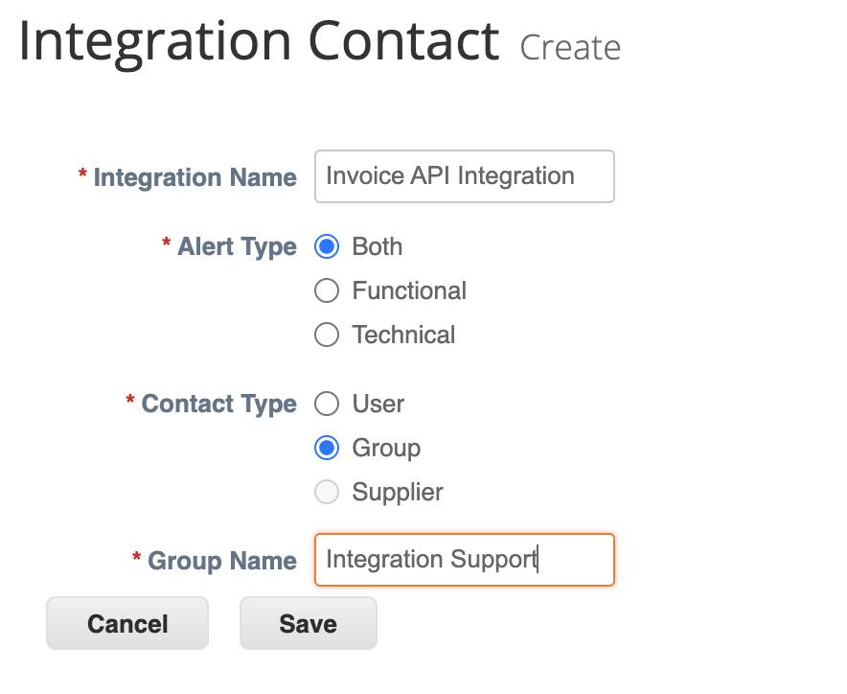

We recommend to have the following option set (request to Coupa Support)

Enable link to Integration History by Document Type
This setting adds a link in the setup page to view full Integration History per document type

Option 1: Simple monitoring based on custom field(s)

Description
In this scenario, for each Invoice we:
- Add the current Integration status in one or several Invoice header custom field(s)

In our example the custom field cf-integration-status was created with name Integration Status

You will use the Standard Invoice Data Table to follow up the Integration status of your documents.

https://<your instance hostname>/invoices
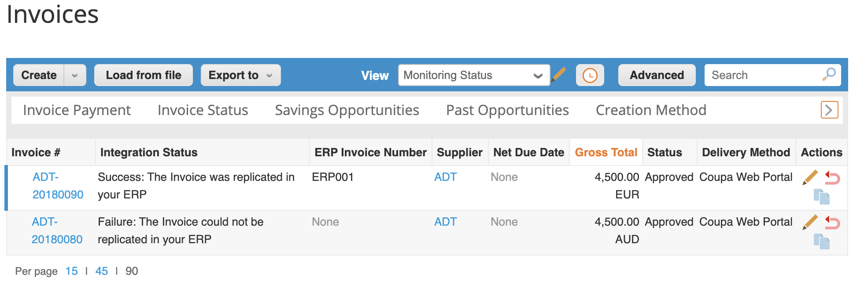

Orchestration Diagram
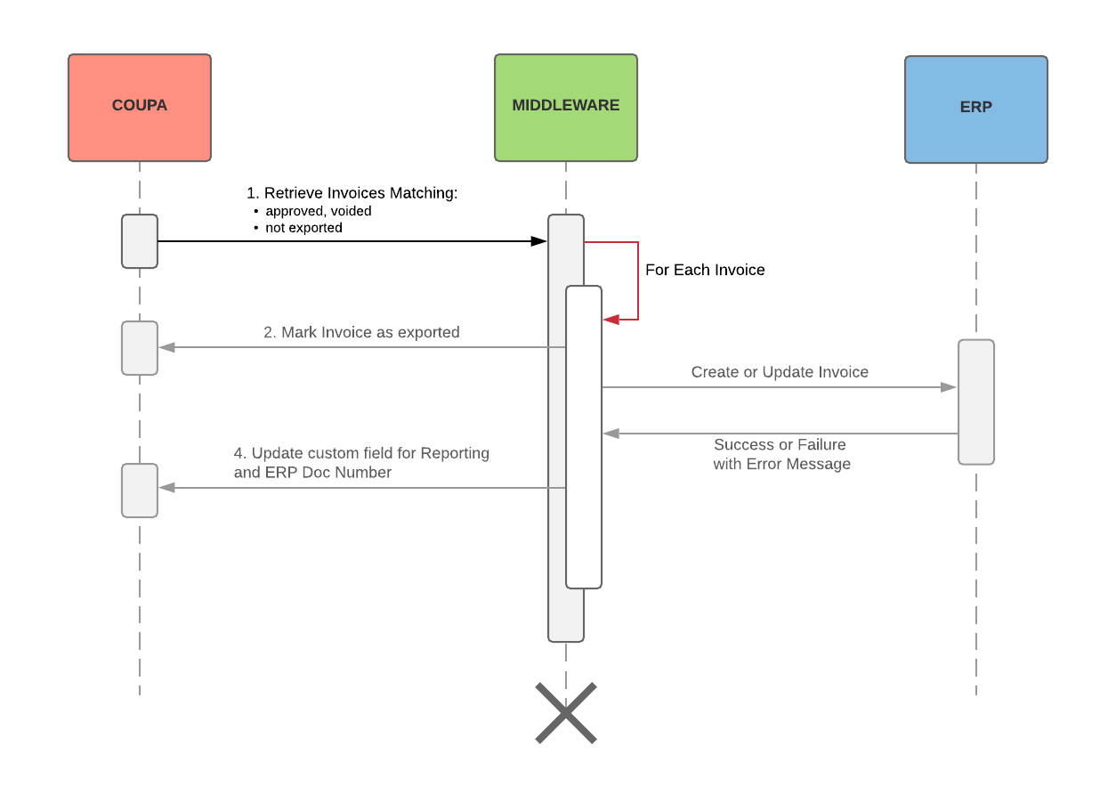

Steps / API calls details

Step 1 | Get the list and details of the Coupa Invoices to create/update in the ERP.  Selection criteria includes the Export Flag and Invoice Status.
Method | GET
API | https://<your instance hostname>/api/invoices/
Query Params | fields=<your API filter name>  offset=10  exported=false  status[in]=approved,voided
Sample URL | https://<your instance hostname>/api/invoices?filter=<your API filter name>&offset=10&exported=false&status[in]=approved,voided
Query Body sample | N/A
Response Body sample | 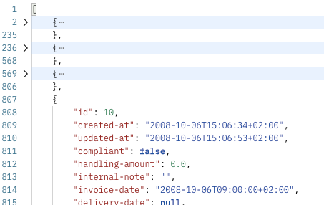

Step 2 | Mark individual Invoice as exported
Method | PUT
API | https://<your instance hostname>/api/invoices/<Invoice id>
Query Params | exported=true  fields=["id","exported"]
Sample URL | https://<your instance hostname>/api/invoices/<Invoice id>?exported=true&fields=["id","exported"]
Query Body sample | N/A
Response Body sample | {  "id": <Invoice id>,  "exported": true  }

That’s where the creation/update of the Invoice in the ERP happens

Step 3 | Update a Custom Fields for Reporting and ERP document number
Method | PUT
API | https://<your instance hostname>/api/invoices/<Invoice id>
Query Params | fields=["id","exported",{ "custom_fields": {} }]
Sample URL | https://<your instance hostname>/api/invoices/<Invoice id>?fields=["id","exported",{ "custom_fields": {} }]
Query Body sample | {  "custom-fields": {  "cf-erp-invoice-number": "<Invoice number in the ERP>",  "cf-integration-status": "Success: The Invoice was replicated in your ERP"  }}  OR  {  "custom-fields": {  "cf-integration-status": "Failure: The Invoice could not be replicated in your ERP"  }}
Response Body sample | { "id": <Invoice id>,  "exported": true,  "custom-fields": {  "cf-erp-invoice-number": "<Invoice number in the ERP>",  "cf-integration-status": "Success: The Invoice was replicated in your ERP"  }}  OR  { "id": <Invoice id>,  "exported": true,  "custom-fields": {  "cf-erp-invoice-number": null,  "cf-integration-status": "Error: The Invoice was properly replicated in your ERP"  }}

Option 2: Advanced monitoring using Integration History

Description
In this scenario, for each Invoice we:
- Resolve the previous Integration History Record for the document
- Create an Integration History Record
- Create an Alert to the Integration Contact in case of an error

Each document includes the Integration History details
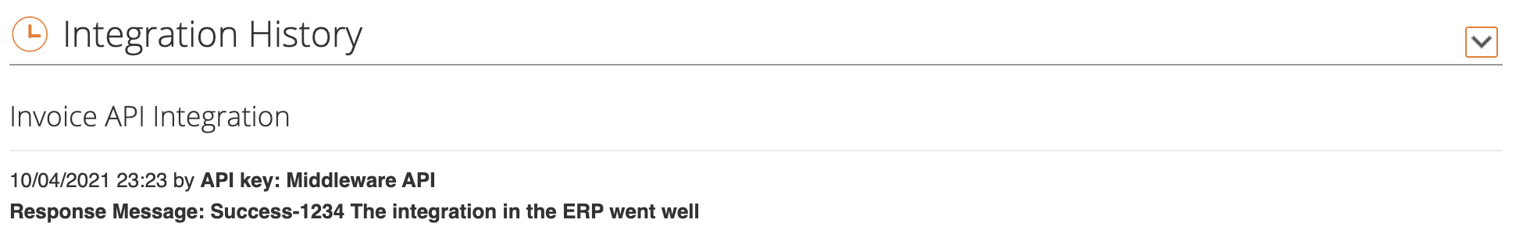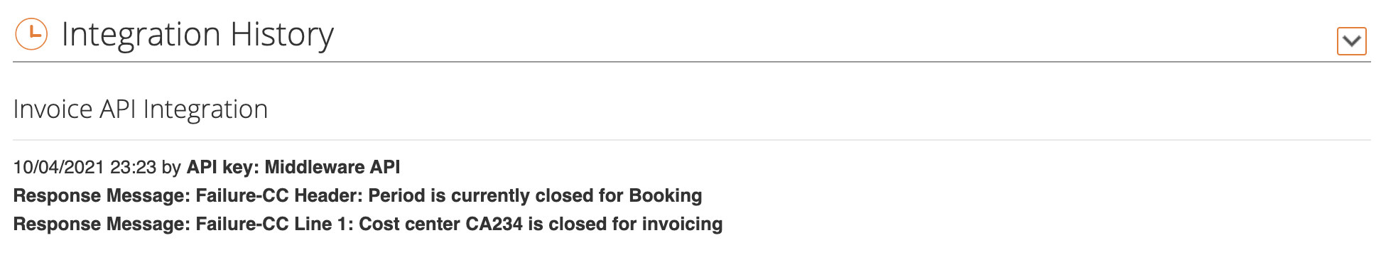

You will use the Standard Invoice Integration History Data Table to follow up the Integration status of your documents

https://<your instance hostname>/integration_history_records/invoices
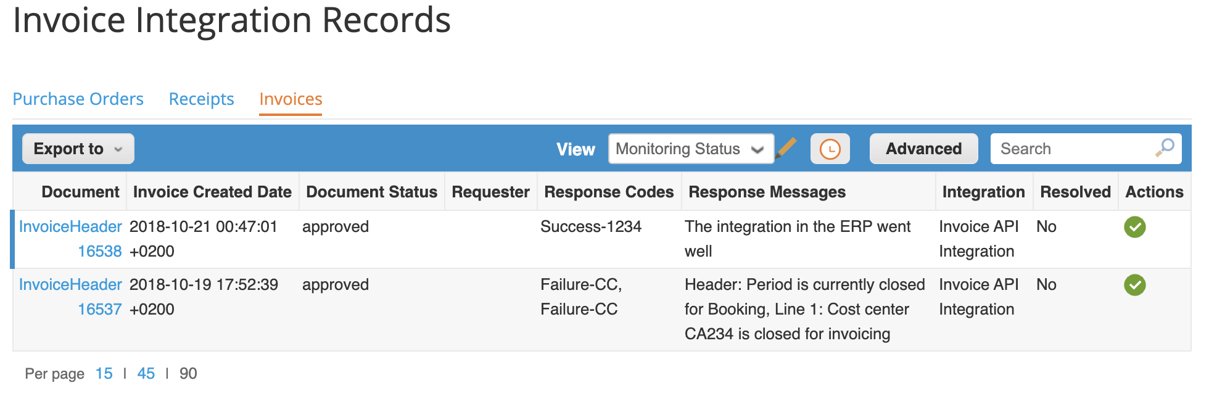

You can use a filter on Response Code to differentiate between documents successfully replicated and documents that failed
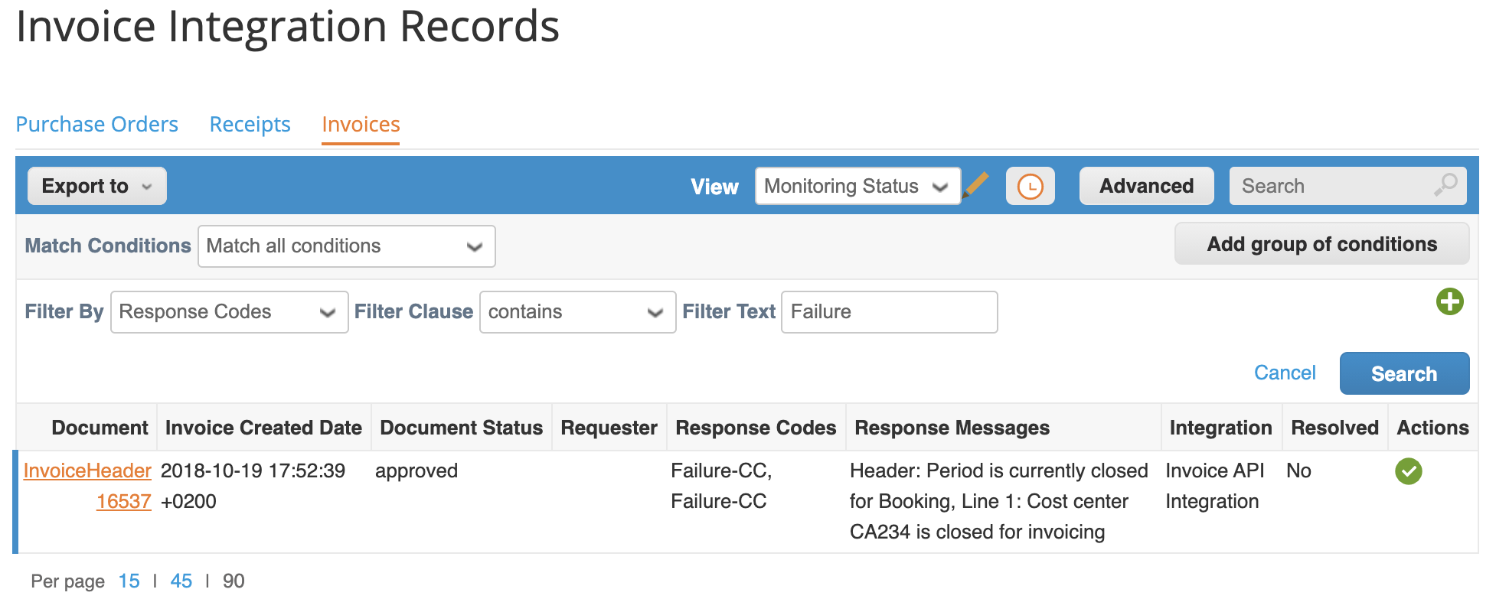

Orchestration Diagram
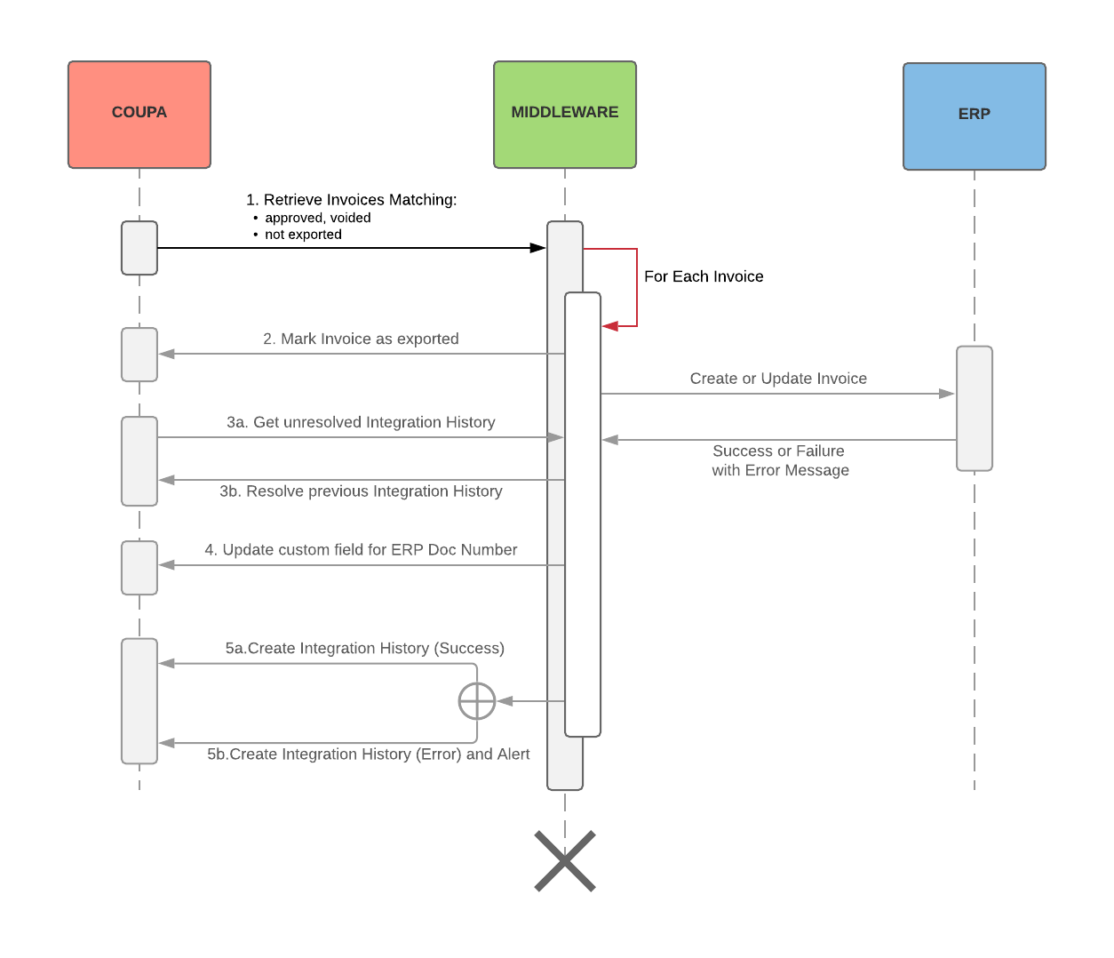

Steps / API calls details

Step 1 | Get the list and details of the Coupa Invoices to create/update in the ERP.  Selection criteria includes the Export Flag and Invoice Status.
Method | GET
API | https://<your instance hostname>/api/invoices/
Query Params | filter=<your API filter name>  offset=10  exported=false  status[in]=approved,voided
Sample URL | https://<your instance hostname>/api/invoices?filter=<your API filter name>&offset=10&exported=false&status[in]=approved,voided
Query Body sample | N/A
Response Body sample

Step 2 | Mark individual Invoice as exported
Method | PUT
API | https://<your instance hostname>/api/invoices/<Invoice id>
Query Params | exported=true  fields=["id","exported"]
Sample URL | https://<your instance hostname>/api/invoices/<Invoice id>?exported=true&fields=["id","exported"]
Query Body sample | N/A
Response Body sample | {  "id": <Invoice id>,  "exported": true  }

That’s where the creation/update of the Invoice in the ERP happens

Step 3a | Get unresolved Integration History Record
Method | GET
API | https://<your instance hostname>/api/integration_history_records
Query Params | resolved=false  document-type=InvoiceHeader  document-id=<Invoice id>  fields=["id","document-id","status","resolved"]
Sample URL | https://<your instance hostname>/api/integration_history_records?resolved=false&document-type=InvoiceHeader&document-id=<Invoice id>&fields=["id","document-id","status","resolved"]
Query Body sample | N/A
Response Body sample | [  {  "id": <Old Integration History Record id>,  "document-id": <Invoice id>,  "status": "Error",  "resolved": false  }  ]

Step 3b | Resolve previous Integration History Record
Method | PUT
API | https://<your instance hostname>/api/integration_history_records/<Old Integration History Record id>/resolve
Query Params | fields=["id","document-id","status","resolved"]
Sample URL | https://<your instance hostname>/api/integration_history_records/<Old Integration History Record id>/resolve?fields=["id","document-id","status","resolved"]
Query Body sample | N/A
Response Body sample | [  {  "id": <Old Integration History Record id>,  "document-id": <Invoice id>,  "status": "Error",  "resolved": true  }  ]

Step 4a | Update a Custom Fields for ERP document number (Success)
Method | PUT
API | https://<your instance hostname>/api/invoices/<Invoice id>
Query Params | fields=["id","exported",{ "custom_fields": {} }]
Sample URL | https://<your instance hostname>/api/invoices/<Invoice id>&fields=["id","exported",{ "custom_fields": {} }]
Query Body sample | {  "custom-fields": {  "cf-erp-invoice-number": "<Invoice number in the ERP>"  }}
Response Body sample | { "id": <Invoice id>,  "exported": true,  "custom-fields": {  "cf-erp-invoice-number": "<Invoice number in the ERP>"  }}

Step 4b | Create Integration History (Success)
Method | PUT
API | https://<your instance hostname>/api/integration_history_records
Query Params | fields=["id","document-id","status"]
Sample URL | https://<your instance hostname>/api/integration_history_records?fields=["id","document-id","status"]
Query Body sample | {  "document-type": "InvoiceHeader",  "document-id": <Invoice id>,  "document-status":"<Invoice status>",  "contact-alert-type": "Functional",  "status": "Success",  "integration": {"code":"<Customer Integration id>"},  "responses": [  {  "response-code": "Success-1234",  "response-message": "The integration in the ERP went well"  }  ]  }
Response Body sample | {  "id": <New Integration History Record id>,  "document-id": <Invoice id>,  "status": "Success"  }

Step 4c | Create Integration History (Error) and alert to Integration Contact
Method | PUT
API | https://<your instance hostname>/api/integration_history_records/create_alert
Query Params | fields=["id","document-id","status"]
Sample URL | https://<your instance hostname>/api/integration_history_records/create_alert?fields=["id","document-id","status"]
Query Body sample | {  "document-type": "InvoiceHeader",  "document-id": <Invoice id>,  "document-status":"<Invoice status>",  "contact-alert-type": "Functional",  "status": "Error",  "integration": {"code":"<Customer Integration id>"},  "responses": [  {  "response-code": "Failure-CC",  "response-message": "Header: Period is currently closed for Booking"  },  {  "response-code": "Failure-CC",  "response-message": "Line 1: Cost center CA234 is closed for invoicing"  }  ]  }
Response Body sample | {  "id": <New Integration History Record id>,  "document-id": <Invoice id>,  "status": "Error"  }

Option 3: Leverage full Coupa Integrations monitoring

Description
In this scenario, we create an Integration run that tracks
- The status of the Integration (pending/started/errored/successful/failed)
- The total number of Invoice processed
- The number of Success and Errors
- The list of Integration Errors and their statuses (resolved or not)

For each Invoice we:
- Resolve the previous Integration History Record for the document
- Create an Integration History Record
- In case of an error, create an Integration Error and an Alert to the Integration Contact

You will be able to monitor all Integration Runs for your Integration

https://<your instance hostname>/integrations/<your integration id>/integration_runs
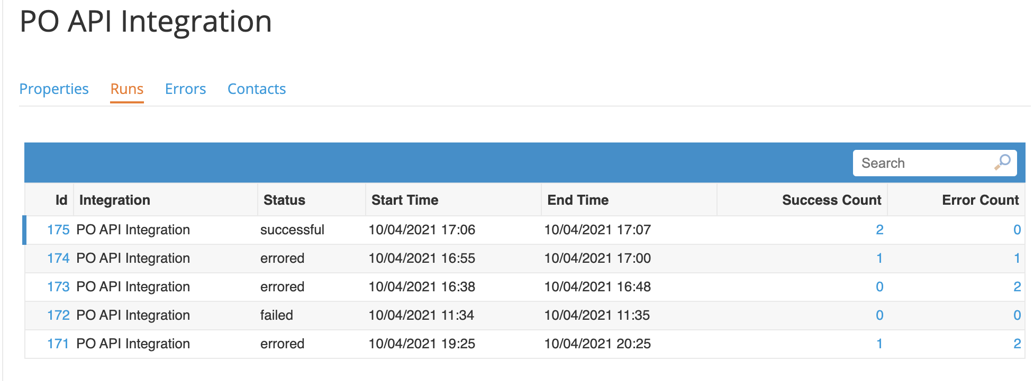

You will use the Standard Invoice Integration Error Data Table to list all Invoices with Integration Error pending resolution

https://<your instance hostname>/integration_errors
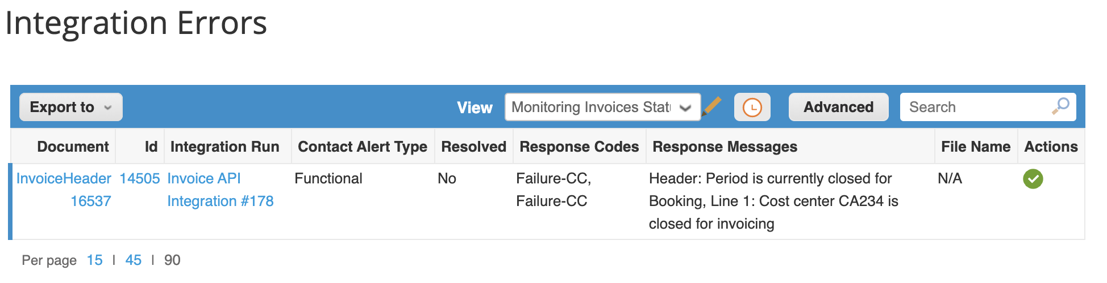

You will use the Standard Invoice Integration History Data Table to list all Invoices successfully Integrated

https://<your instance hostname>/integration_history_records/invoices
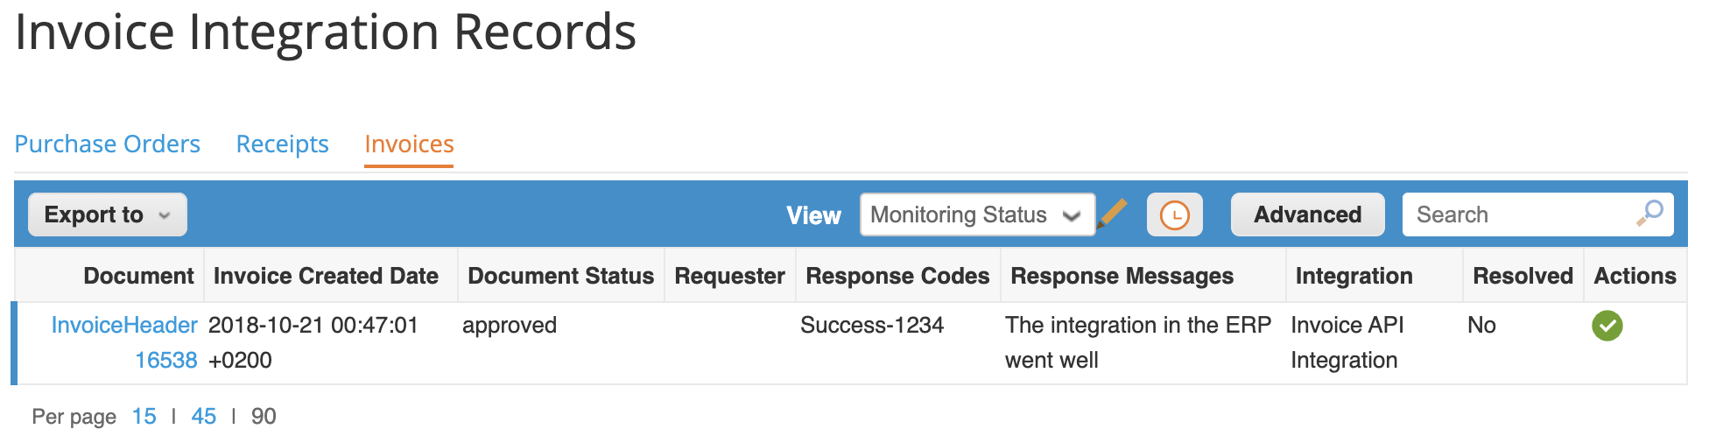

Orchestration Diagram
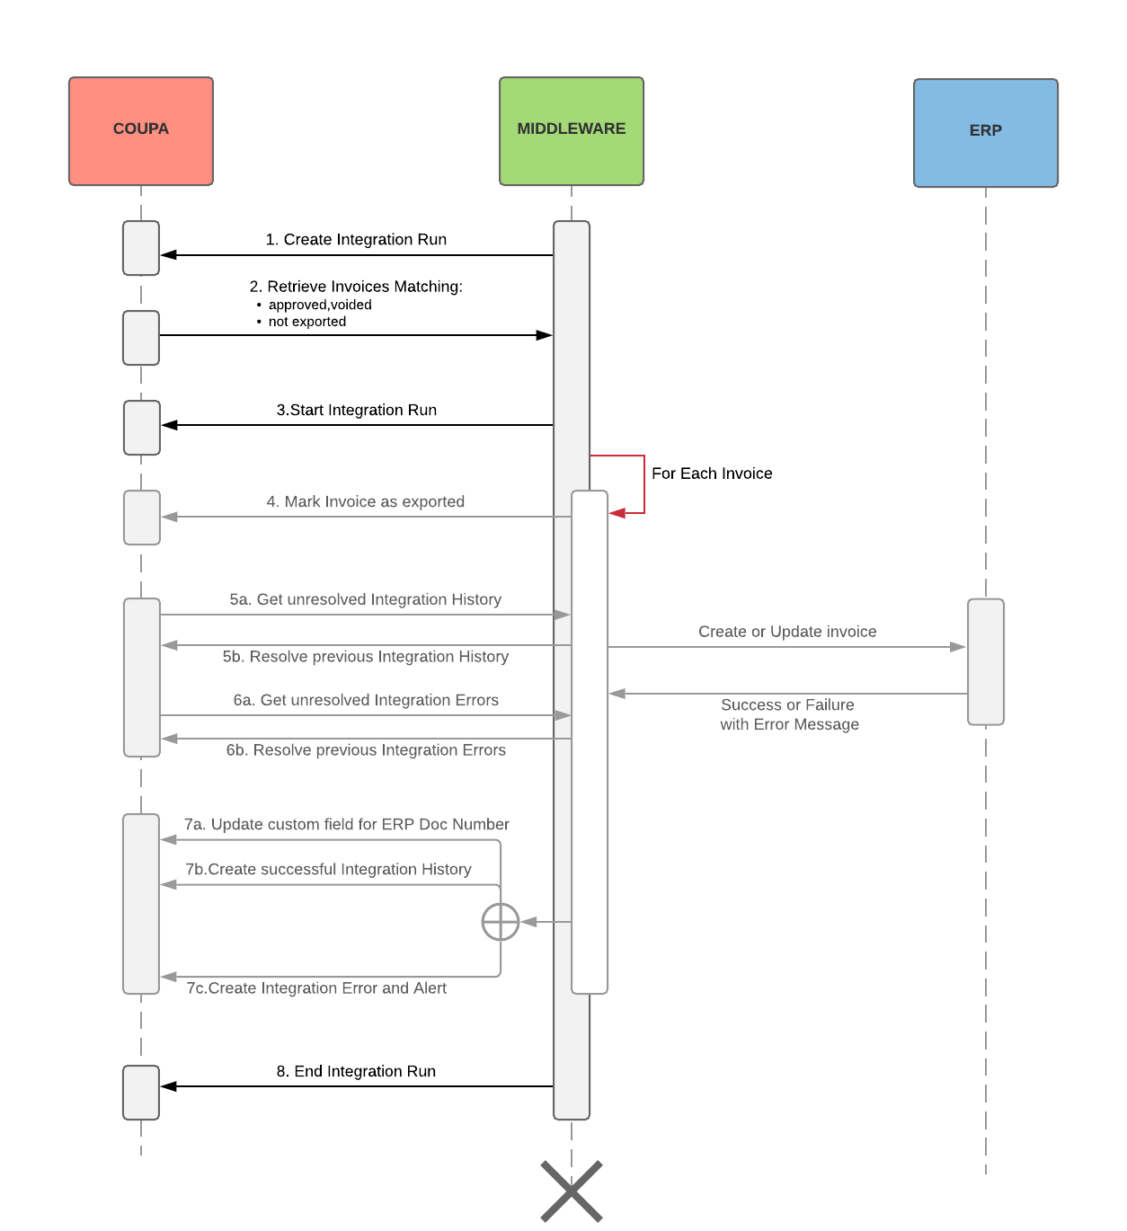

Steps / API calls details

Step 1 | Create Integration Run
Method | POST
API | https://<your instance hostname>/api/integration_runs
Query Params | N/A
Query Body sample | {  "integration": {  "code": "{{Integration_Code}}"  }}
Response Body sample | {  "id": <Integration Run ID>,  ...  }

Step 2 | Get the list and details of the Coupa Invoices to create/update in the ERP.  Selection criteria includes the Export Flag and Invoice Status.
Method | GET
API | https://<your instance hostname>/api/invoices/
Query Params | filter=<your API filter name>  offset=10  exported=false  status[in]=approved,voided
Sample URL | https://<your instance hostname>/api/invoices?filter=<your API filter name>&offset=10&exported=false&status[in]=approved,voided
Query Body sample | N/A
Response Body sample

Step 3 | Start Integration Run
Method | PUT
API | https://<your instance hostname>/api/integration_runs/<Integration Run ID>/run
Query Params | N/A
Query Body sample | {  "total_records": <Total Number of Invoices from Step 2>  }
Response Body sample | {  "id": <Integration Run ID>,  ...  }

Step 4 | Mark individual Invoice as exported
Method | PUT
API | https://<your instance hostname>/api/invoices/<Invoice id>
Query Params | exported=true  fields=["id","exported"]
Sample URL | https://<your instance hostname>/api/invoices/<Invoice id>?exported=true  fields=["id","exported"]
Query Body sample | N/A
Response Body sample | {  "id": <Invoice id>,  "exported": true  }

That’s where the creation/update of the Invoice in the ERP happens

Step 5a | Get unresolved Integration History Record
Method | GET
API | https://<your instance hostname>/api/integration_history_records
Query Params | resolved=false  document-type=InvoiceHeader  document-id=<Invoice id>  fields=["id","document-id","status","resolved"]
Sample URL | https://<your instance hostname>/api/integration_history_records?resolved=false&document-type=InvoiceHeader&document-id=<Invoice id>&fields=["id","document-id","status","resolved"]
Query Body sample | N/A
Response Body sample | [  {  "id": <Old Integration History Record id>,  "document-id": <Invoice id>,  "status": "Error",  "resolved": false  }  ]

Step 5b | Resolve previous Integration History Record
Method | PUT
API | https://<your instance hostname>/api/integration_history_records/<Old Integration History Record id>/resolve
Query Params | fields=["id","document-id","status","resolved"]
Sample URL | https://<your instance hostname>/api/integration_history_records/<Old Integration History Record id>/resolve?fields=["id","document-id","status","resolved"]
Query Body sample | N/A
Response Body sample | [  {  "id": <Old Integration History Record id>,  "document-id": <Invoice id>,  "status": "Error",  "resolved": true  }  ]

Step 6a | Get unresolved Integration Error Record
Method | GET
API | https://<your instance hostname>/api/integration_errors
Query Params | resolved=false  document-type=InvoiceHeader  document-id=<Invoice id>
Sample URL | https://<your instance hostname>/api/integration_errors?resolved=false&document-type=InvoiceHeader&document-id=<Invoice id>
Query Body sample | N/A
Response Body sample | [  {  "id": <Old Integration Error Record id>,  "document-type": ”InvoiceHeader”,  "document-id": <Invoice id>,  "status": "Error",  "resolved": false  ...  }  ]

Step 6b | Resolve previous Integration History Record
Method | PUT
API | https://<your instance hostname>/api/integration_errors/<Old Integration Error Record id>/resolve
Query Params | N/A
Query Body sample | N/A
Response Body sample | [  {  "id": <Old Integration Error Record id>,  "document-id": <Invoice id>,  "status": "Error",  "resolved": true  ...  }  ]

Step 7a | Update a Custom Fields for ERP document number (Success)
Method | PUT
API | https://<your instance hostname>/api/invoices/<Invoice id>
Query Params | fields=["id","exported",{ "custom_fields": {} }]
Sample URL | https://<your instance hostname>/api/invoices/<Invoice id>?fields=["id","exported",{ "custom_fields": {} }]
Query Body sample | {  "custom-fields": {  "cf-erp-invoice-number": "<Invoice number in the ERP>"  }}
Response Body sample | { "id": <Invoice id>,  "exported": true,  "custom-fields": {  "cf-erp-invoice-number": "<Invoice number in the ERP>"  }}

Step 7b | Create Integration History (Success)  It must reference the Integration Run
Method | PUT
API | https://<your instance hostname>/api/integration_history_records
Query Params | fields=["id","document-id","status"]
Sample URL | https://<your instance hostname>/api/integration_history_records?fields=["id","document-id","status"]
Query Body sample | {  "document-type": "InvoiceHeader",  "document-id": <Invoice id>,  "document-status":"<Invoice status>",  "contact-alert-type": "Functional",  "status": "Success",  "integration": {"code":"<Customer Integration id>"},  "integration-run": {"id":<Integration Run ID>},  "responses": [  {  "response-code": "Success-1234",  "response-message": "The integration in the ERP went well"  }  ]}
Response Body sample | {  "id": <New Integration History Record id>,  "document-id": <Invoice id>,  "status": "Success"  }

Step 7c | Create Integration Error and alert to Integration Contact  It must reference the Integration Run
Method | PUT
API | https://<your instance hostname>/api/integration_errors/create_alert
Query Params | N/A
Query Body sample | {  "document-type": "InvoiceHeader",  "document-id": <Invoice id>,  "document-status":"<Invoice status>",  "contact-alert-type": "Functional",  "status": "Error",  "integration-run-id": "<Integration Run ID>",  "responses": [  {  "response-code": "Failure-CC", "response-message": "Header: Period is currently closed for Booking"  },  {  "response-code": "Failure-CC",  "response-message": "Line 1: Cost center CA234 is closed for invoicing"  }  ]  }
Response Body sample | {  "id": <New Integration Error Record id>,  "document-id": <Invoice id>,  "status": "Error"  ...  }

Step 8 | Successfully End Integration Run
Method | PUT
API | https://<your instance hostname>/api/integration_runs/<Integration Run ID>/success
Query Params | N/A
Query Body sample | N/A
Response Body sample | {  "id": <Integration Run ID>,  "status": "successful"  ...  }

If there is a general failure during the Integration run

Step x | Raise Failure for the Integration Run
Method | PUT
API | https://<your instance hostname>/api/integration_runs/<Integration Run ID>/fail
Query Params | N/A
Query Body sample | N/A
Response Body sample | {  "id": <Integration Run ID>,  "status": "failed"  ...  }

